**Functional Requirement Document**

**for an auto shop application-**

**Velocity Vehicles**

|  |  |
| --- | --- |
| **SECTION** | **PAGE NO.** |
| 1. Introduction | 1 |
| * 1. Purpose | 1 |
| * 1. Intended Audience | 1 |
| 1. Functional Requirements | 1-5 |
| * 1. 2Home Page | 1-2 |
| * + 1. Top Navigation Bar | 1 |
| * + 1. Landing Section | 1 |
| * 1. Explore our Premium brands | 2-3 |
| * + 1. Car Detail Based on specific Brand | 3 |
| * 1. Explore All Vehicles Section | 4-5 |
| * + 1. Selected Car Details | 4 |
| 1. User Roles | 6-8 |
| * 1. Customer | 6 |
| * 1. Dealers | 6 |
| * + 1. Dealer Page Sections | 6 |
| 1. Responsiveness & Accessibility | 8 |
| 1. Summary | 8 |

**CONTENT**

1. **Introduction**

The Functional Requirement Document (FRD) outlines the functional aspects and behaviour of the web-based application Velocity Vehicles. It serves as a guide for the development, testing, and deployment teams to understand how the system is expected to function for end-users and admin dealers.

**1.1 Purpose**

This FRD defines the functional specifications and expected behaviours of the Velocity Vehicles platform. It serves as a contractual document among developers, designers, testers, and stakeholders, ensuring a clear understanding of the system before implementation.

**1.2 Intended Audience**

* Development Team
* Testing/QA Team
* UI/UX Designers
* Database Team
* Project Stakeholders
* Business Analysts

1. **Functional Requirements**

When the user types the URL, it should navigate to the Home page of the Velocity Vehicles website.

**2.1 Home Page**

The homepage is **scrollable** and dynamically reveals sections as the user scrolls. It is designed to be visually rich and highly interactive.

* + 1. **Top Navigation Bar**
* Positioned as a sticky header, always visible.
* Contains:
  + **Logo**: Top-left corner.
  + Navigation Links: **Home**, **About Us**, **Contact Us**, **Sign In** (for both users and dealers).
* Fully responsive, collapses into a hamburger menu on mobile.

**2.1.2 Landing Section**

* Central slogan/tagline that represents the brand vision. Below the slogan, six **primary category buttons**:
  + **SUV**, **Sedan**, **Hatchback**, **Coupe**, **MVP**, **MUV**
* Each button, when clicked, dynamically reveals a set of filters:
  + **Brand Type** (e.g., Tata, BMW, Hyundai)
  + **Fuel Type** (Petrol, Diesel, CNG)
* **Mileage Range** (Min–Max, in kmpl)
* **Price Range** (Min–Max input )

The **"Search "** button is positioned on the right of the filter section and triggers a query to list all cars matching the criteria.

(Landing Home page screen is shown in the **Figure 2.1.2**)

Figure 2.1.2

* 1. **Explore Our Premium Brands**
* Follows immediately after the landing section.
* Contains the heading: **"Explore Our Premium Brands”.**
* A set of **clickable brand cards** is displayed for visual branding and is then redirected to the selected Brand Page showing all the cars present with the dealers.

(Explore Our Premium Brands section is shown in the **Figure 2.2**)

* **Tata**, **BMW**, **Ford**, **Mercedes Benz**, **Hyundai**, **Mahindra, Toyota, Maruti Suzuki, Honda**
* A screenshot of a screenshot of a company logo

  AI-generated content may be incorrect.Each card shows Brand Logo and Brand Name in stylized font.

Figure 2.2

**2.2.1 Car Details Based on specific Brand.**

* At the top of the page the selected Brand name is mentioned for user reference and clarity.
* Filter Section: For the user to refine their results, there is a sidebar with various categories, each with a dropdown of their own, that shows the various options available in that category when clicked.
* The categories in the sidebar as dropdown options are:
* Price range
* Vehicle type
* Fuel type
* Transmission Type
* Seating Capacity
* Mileage range
* Display Section: To the right of the sidebar, the entire page is the scrollable display section, which displays the cards for all the cars that match the filters of the user. Each card consists of details about the car such as its
* Full Name
* Rating
* Vehicle Type
* Price
* Mileage
* Transmission Type
* Fuel Type
* Engine
* Power
* “Check for More Details” button will redirect the user to the page of the specific selected car for the user to view all the details of the car.

Figure 2.2.1

**2.3 Explore All Vehicles Section**

* Displays a catalogue/grid of all available vehicles in the system.
* Each card includes the following:
  + **Image of the Car**
  + **Model Name**
  + **Price** (in Rs.)
  + **Mileage** (km/l or km/kWh)
  + **Fuel Type** (Petrol, Diesel, CNG)
  + **Transmission Type** (Manual or Automatic)
* The “View All” button will again redirect to the page with all the cars details which can be further filtered as per the requirements.
* A screenshot of a car

  AI-generated content may be incorrect.Cards are responsive and include a hover effect for more engagement.

Figure 2.3

**2.3.1 Selected Car Details**

* When a user selects or clicks on a specific car from the Explore All Vehicles section or a filtered listing, they are redirected to the Car Detail Page. This page presents a comprehensive, visually organized view of the selected car model through a structured card-based layout as shown bellow:

**Card 1: Car Image Carousel**

* + A high-resolution image carousel showing the picture of the car.

**Card 2: Car Specifications**

* + A dedicated specification card listing the car’s technical and physical details - Engine(cc), Cylinders, Gears, Mileage, Power, Torque, Transmission, Fuel Capacity, Seating Capacity, Warranty, Fuel Type, Steering.

**Card 3: Basic Details & Actions**

* + Positioned prominently near the top or top-right of the page containing Car Name, Brand Name, Showroom Price, etc.
  + "Book Now" button leads to a booking and then allocating the car to the specific user.
  + "Free Test Drive" button opens a form to schedule a test drive, asking for preferred time, location, and user contact details.

**Card 4: Top Features of this car**

This card presents a list of top features of the car like Advanced Ventilation System, Dual or Multi-Airbags, etc.

(Image of the page is shown below in **Figure 2.3.1**)

**Card 5: Car Location**

This card displays the location of the car present.

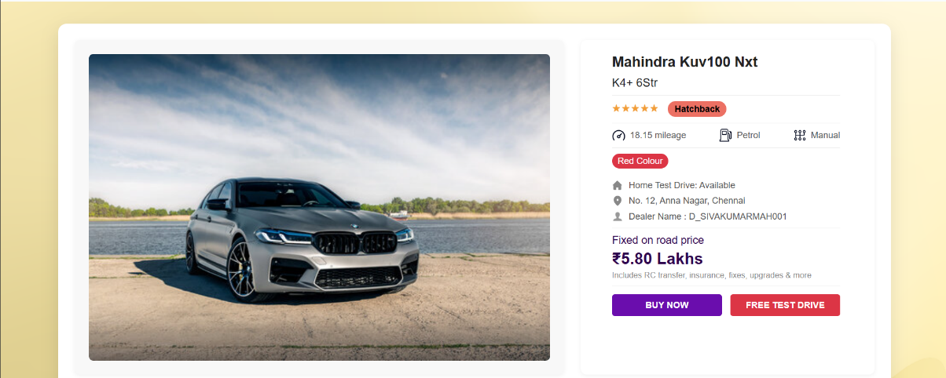

**Figure 2.3.1**

The Home Page then contains a section to display the list of Dealers associated with our Velocity Vehicles followed by the footer section as shown below in **Figure 2.3.2**.

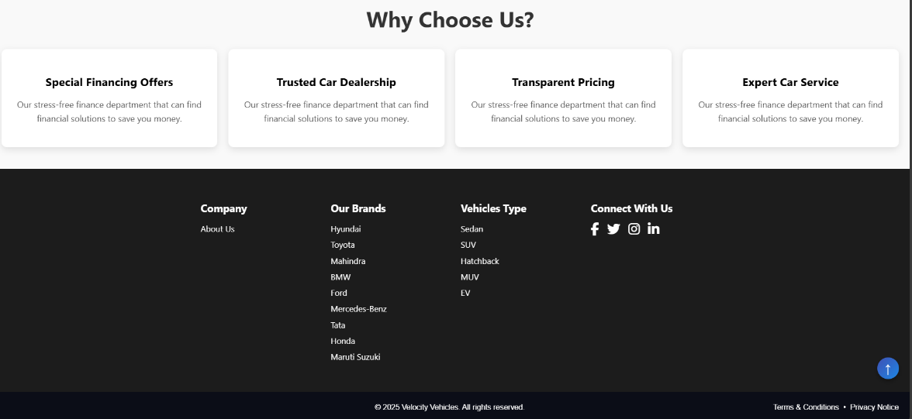

**Figure 2.3.2**

1. **User**

**3.1 Customer**

* For the customers the Sign In and login pages are opened as per the requirements to explore vehicles as shown in the **Figure 3.1.1** and **Figure 3.1.2**.

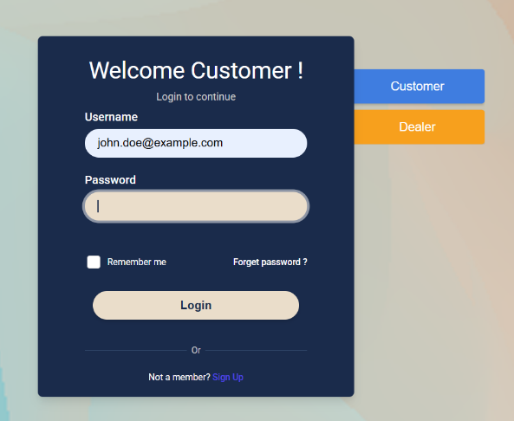

**Figure 3.1.1** **Figure 3.1.2**

**3.2 Dealers**

* For the Dealer the Sign Up and log in pages are opened as per the requirements to explore vehicles as shown in the **Figure 3.2.1** and **Figure 3.2.2**.

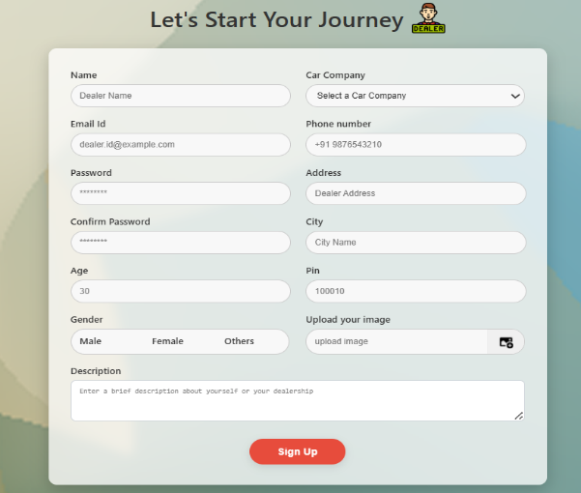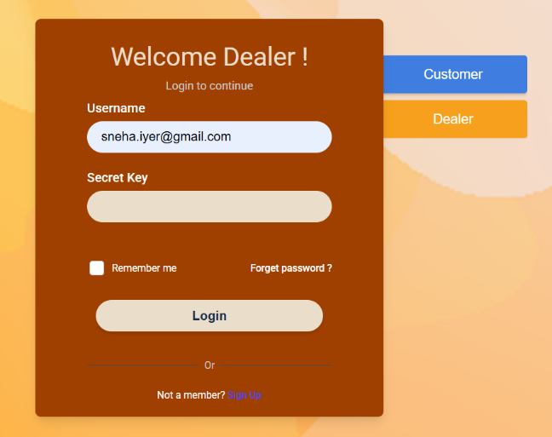

**Figure 3.2.1 Figure 3.2.2**

* **Navbar:**
  + Logo – in the top left corner there will be the company logo.
  + Profile icon – in the top right corner there will be the dealer profile icon present.
  + Home - this is a default home button.
  + About us – this will redirect to the about us page.
  + Contact us – this will redirect you to a page containing our Contact Details.
* **Dealer Page:**
  + Profile Photo – in the left side of the dashboard there will be a profile photo of the dealer.
  + Dealer Description section -Right side of the dashboard is the dealer description. This follow details will show in the dealer’s description such as Name, Username, brand name, etc.
  + Contains a brief description of the dealer.
* **Cars in stock**
  + Cars List in the form of cards (which is a smaller description of the car). By clicking in the card of the car. It will redirect us to the specified car view page.

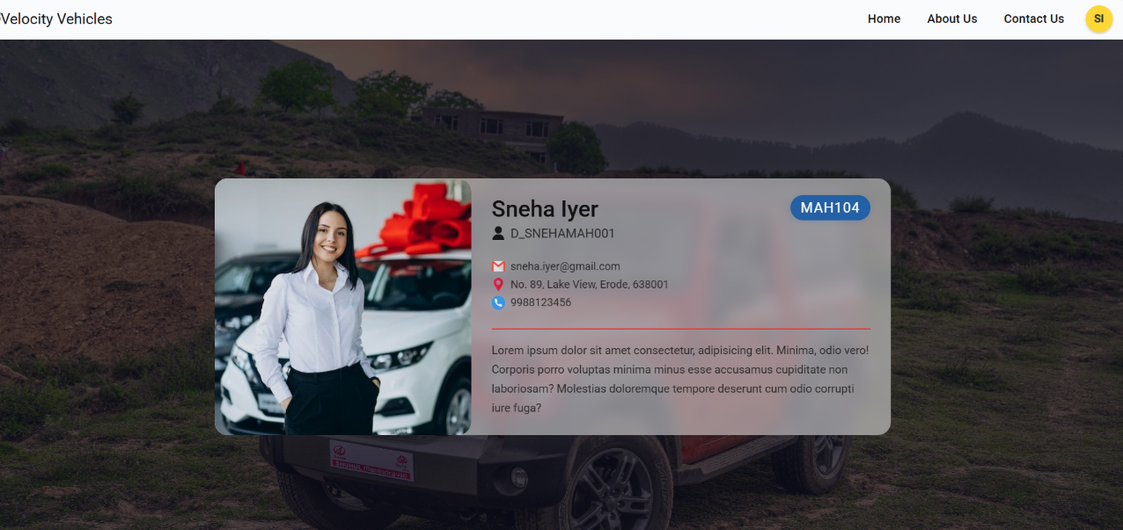

**Figure 3.2.5**

* **Profile Menu**

To the right of the page is the Profile Menu of the dealer clicking on which we get the following options- Profile, Notification, Sold cars, Add car and Sign Out (shown in Figure 3.2.6)

* + Profile button has the initial letters of the first name and last name of the dealer.
  + It is followed by the Name and email address of the dealer.
  + On Clicking the **Profile** option it redirects you to the **Dealer** **Dashboard** (shown in Figure 3.2.7) which contains Dealers information on the left and on the right is a donut pie-chart showing Available cars and Sold cars, followed by Inventory breakdown.
  + On clicking the **Notification** button it redirects to the Notification page(shown in figure 3.2.8) for the dealer showing All Requests, Buy Request and Test Drive Requests.
  + On clicking **Sold Cars** button it redirects to the page giving details in the cars sold by the dealer(shown in Figure 3.2.9).
  + On clicking **Add Car** button it redirects to the Add car details page where the dealer adds the car to the inventory(shown in figure 3.2.10)
  + On clicking **Sign Out** the dealer is signed out .

**Figure 3.2.7**

**Figure 3.2.6**

**Figure 3.2.8**

**Figure 3.2.9**

**Figure 3.2.10**

1. **Responsiveness & Accessibility**

* Fully responsive on all devices (desktop, tablet, mobile).
* Elements like filter panels collapse into accordions on smaller screens.
* All forms and navigation are keyboard accessible.

1. **Summary**

**Velocity Vehicles** aims to provide a seamless and efficient experience for users to explore and compare cars, while empowering dealers with the tools to manage and promote their inventory. With a secure backend, intuitive UI, and responsive design, this platform serves as a scalable auto dealership solution built with Java Spring technologies.